*1. What are the three longest trips on rainy days?*

WITH

trip_length

AS (

SELECT

LEFT(start_date, 10) as tdate,

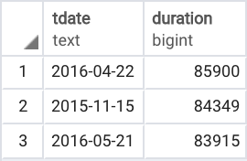 duration

FROM trips

)

SELECT

t.tdate,

t.duration

FROM

trip_length t

JOIN

weather w

ON t.tdate = w.date

WHERE w.events = 'Rain'

GROUP BY t.tdate, t.duration

ORDER BY t.duration DESC

LIMIT 3;

2. Which station is full most often?

Full equals the most bikes available for subscribers to use.

ANSWER: San Jose Diridon Caltrain Station

WITH

full_station

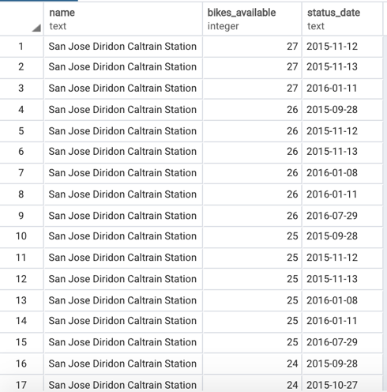AS (

SELECT status.station_id,

status.bikes_available,

LEFT(timestamp, 10) as status_date

FROM status

)

SELECT stations.name,

full_station.bikes_available,

full_station.status_date

FROM stations

JOIN full_station

ON stations.station_id = full_station.station_id

GROUP BY full_station.status_date,

stations.name,

full_station.bikes_available

ORDER BY full_station.bikes_available DESC,

stations.name;

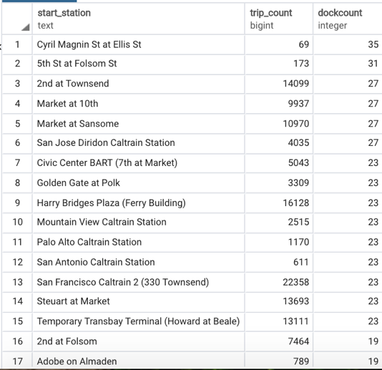3. Return a list of stations with a count of the number of trips starting at that station but ordered by dock count?

SELECT trips.start_station,

COUNT(trips.trip_id) AS trip_count,

stations.dockcount

FROM trips

JOIN stations

ON trips.start_station = stations.name

GROUP BY trips.start_station,

stations.dockcount

ORDER BY stations.dockcount DESC, trips.start_station;

4. Challenge: What's the length of the longest trip for each day it rains anywhere?

WITH

trip_length

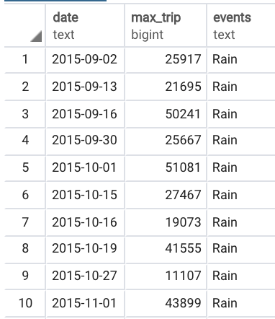AS (

SELECT duration,

LEFT(start_date, 10) as trip_date

FROM trips

GROUP BY trip_date,

duration

)

SELECT w.date,

MAX(t.duration) as max_trip,

w.events

FROM weather w

JOIN trip_length t

ON w.date = t.trip_date

WHERE w.events = ‘Rain’

GROUP BY w.date, w.events

ORDER BY w.date;